Step 1: Statistics or Telephony – RTP- Show All Streams

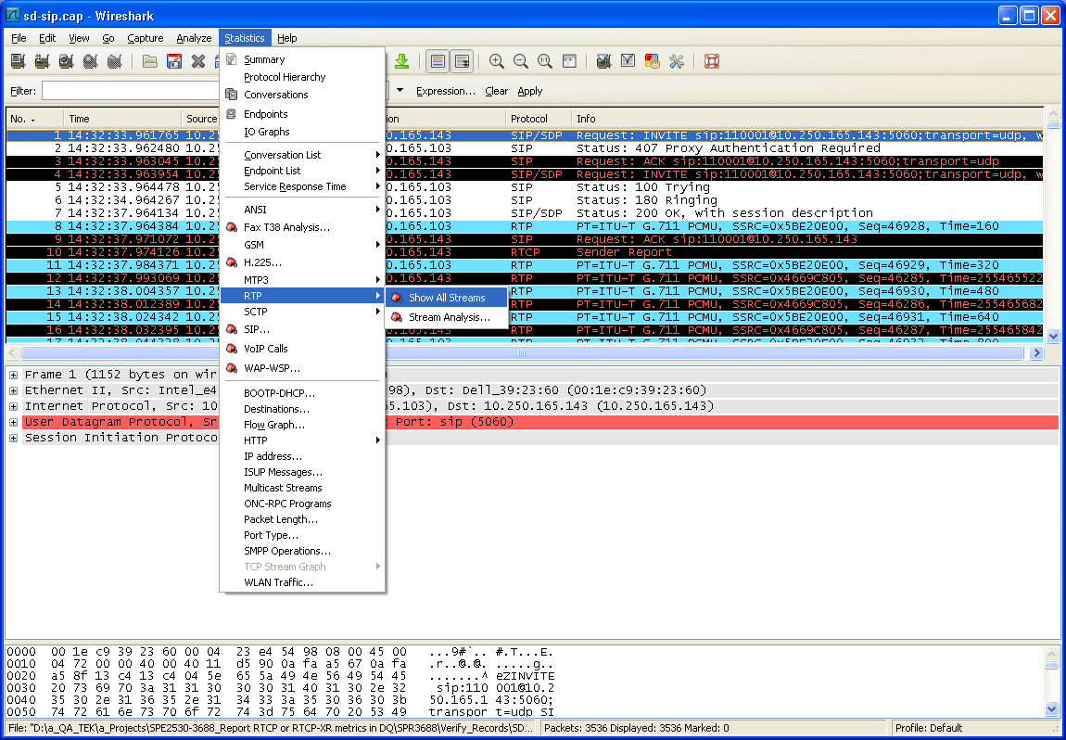

Step 2: Select one stream and click Analyze
Note: select the Src and Dest IP you want to analyze. For example, you want to analyze DO direction, select Src IP – TRU, Dest IP – ORU.

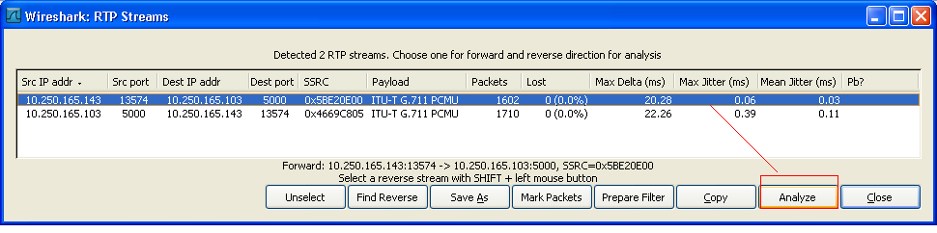

Step 3: Then you will see below window. Select Forward Direction and click Save payload.

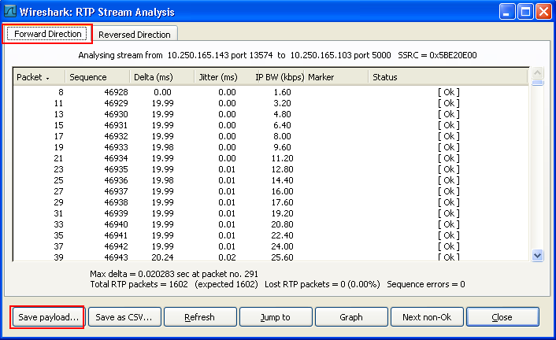

Step 4: Select a path, select Format - .au, Channels – forward, and put a filename to save, and click OK.

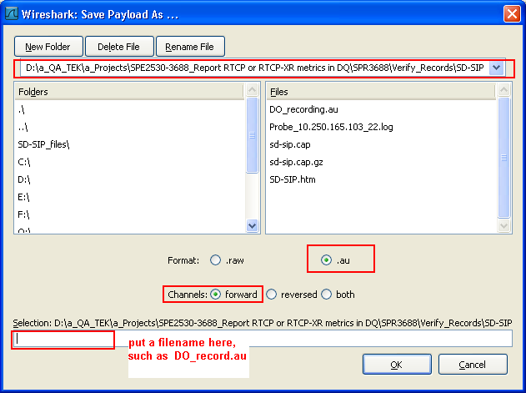

Step 5: Open the saved .au file with CoolEdit.

